

**MIDDLE EAST TECHNICAL UNIVERSITY**

**DEPARTMENT OF ELECTRICAL & ELECTRONICS ENGINEERING**

**E463 – PROJECT #1**

**İven ()**

**Etki Açılan (2165694)**

# **INTRODUCTION**

1. **SINGLE PHASE DIODE RECTIFIER**

a)

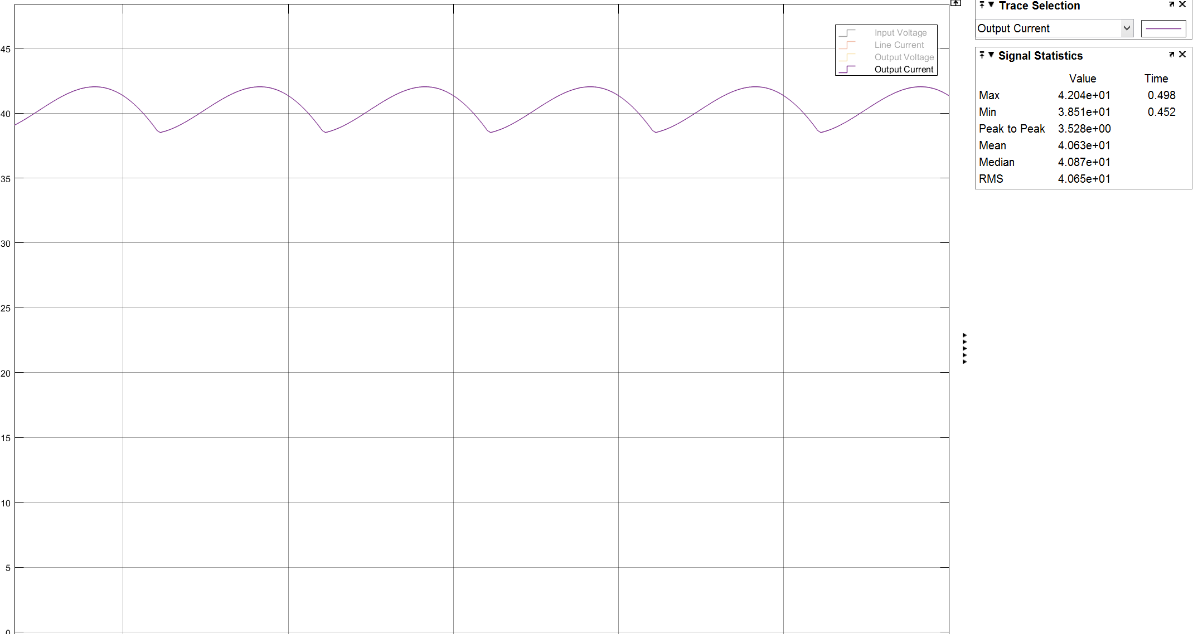

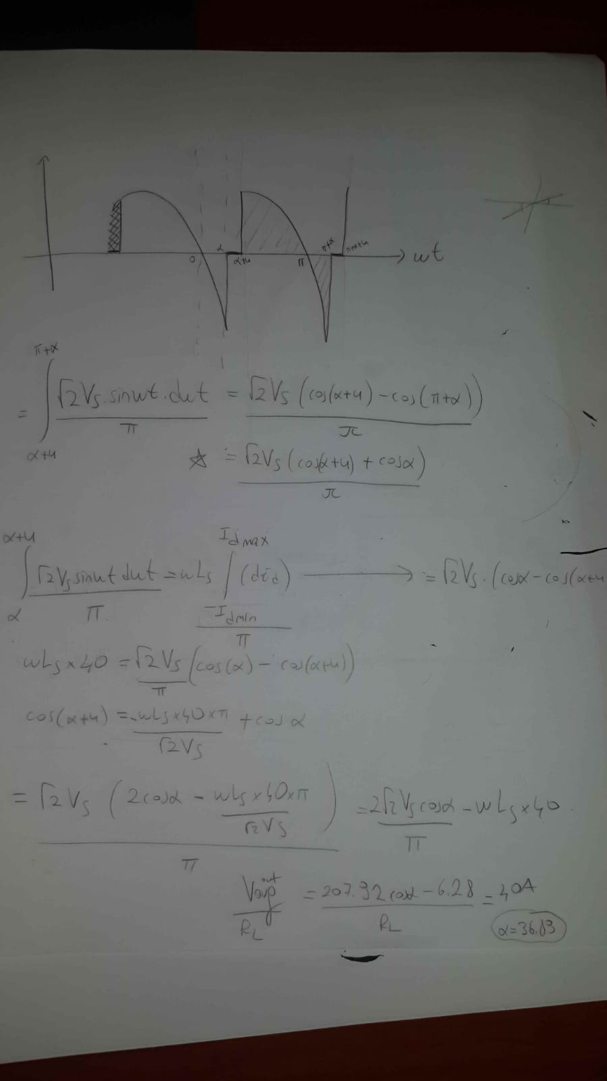

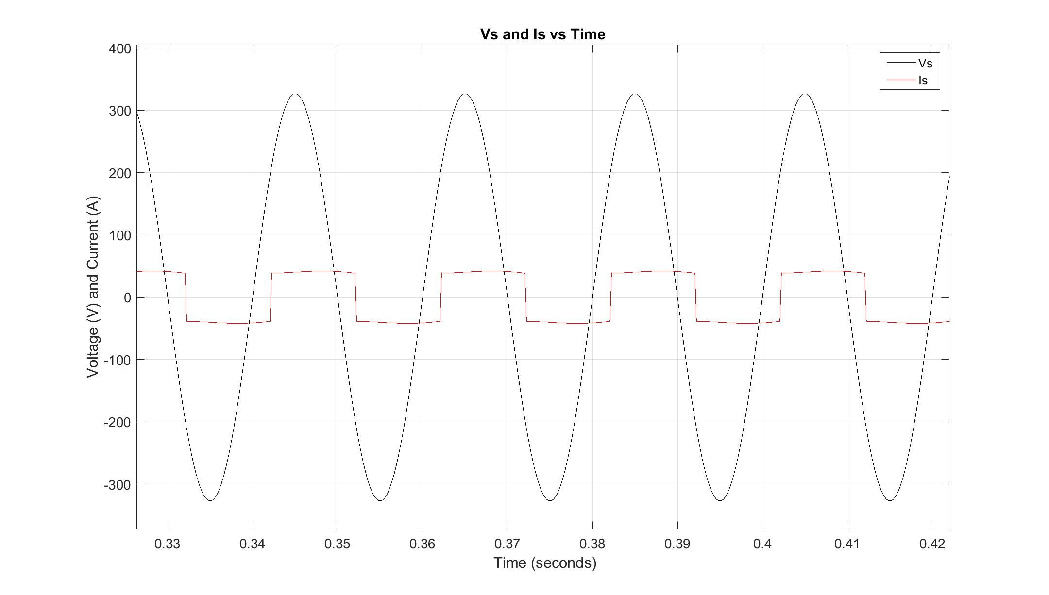

Is Vs Time a)

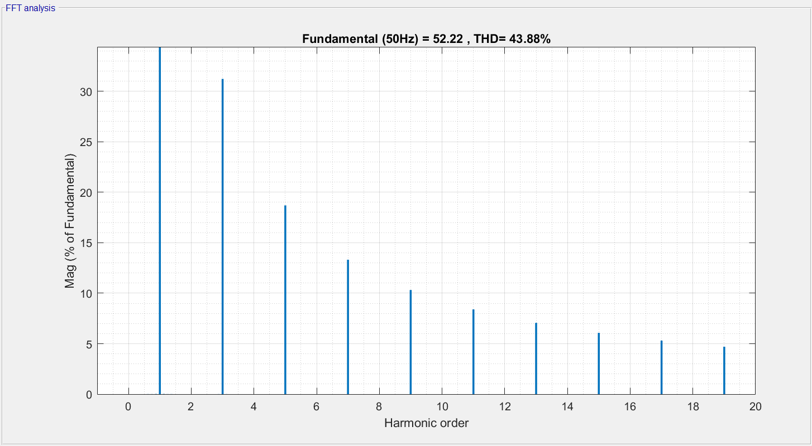

THD line current a

b)

